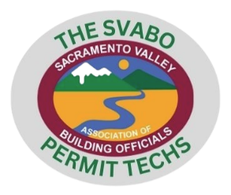
The SVABO Permit Techs Agenda

Date: March 13, 2024 Time: 4:00pm Location: Microsoft Teams
Attendance: Total meeting minutes:

Brief recap of February meeting
- Goals for the committee
- Focus for remainder of the year
- Monthly meetings instead of bi-monthly meeting
- SVABO updates and education
- Resources for the permit technicians
- Shared drive created and shared with techs

- Building Safety Month – May 2024
  - What is your jurisdiction doing to participate?
  - Do you have resources to share with the team?

- Topics for Monthly Newsletters:
Role of Permit Technician – Brief description
- Pathway to obtain PT Certificate
- Mentoring signs up
- Monthly Newsletter
- Permit Types (survey)
- Permitting Software Used (survey)

- ADUs / JADUs
  - Addressing
  - Plans (resources and requirements)
  - Impact Fees
  - Size Requirements
  - School Fees

- Notice of Violation / Stop Work Order
  - Procedures
  - Flowcharts
  - Handouts/Resources

