Sacramento Valley Association of Building Officials
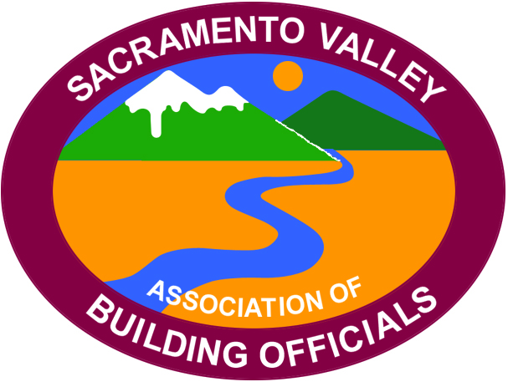

President
Jon May
City of Grass Valley
(530) 274-4717

Vice President
Roxanna Recinos-Serna
City of West Sacramento
(916) 617-4683

Secretary/Treasurer
Will Foote
City of Lincoln
(916) 434-2485

Past President
Nick Henderson
4Leaf, Inc.
(925) 462-5959

Minutes of the February 10th
SVABO General Meeting
Host City:

- Call meeting to order
Meeting called to order by Board President May (BPM) at 10:05 AM with 22 people in attendance and 7 people online.

- Thank you to host City- Grass Valley
BPM welcomed the host-Jon May

- Welcome by host
Board president Jon May

- Flag salute
Led by Jay Hyde

- Self-introductions
Self-introductions of Officers, Board members and all in attendance.

- Review of January Meeting Minutes
Motion to approve meeting minutes by Joe Cuffe Seconded by unanimous vote.

- Executive Board Reports:
a. Secretary/Treasurer Report – Will Foote
i. As of January 31st 2023, the account balance is 43,640.45

b. Vice-President’s Report – Roxanna Recinos-Serna
i. Announcement of the March 10th meeting to be hosted by West Sacramento at Villara, to include a tour and presentation.

c. President’s Report – Jon May
i. Education institute is under way! The website is up and tickets are available.
ii. Website cooperation- gather other ICC chapters and integrate their news and information with the idea they will do the same.
iii. Encourage committee participation from your staff.

d. Past-President’s Report – Nick Henderson- Not present

- Code Quiz – Bill Rodgers

- Committee Chair Reports
  - Code Review and Development – Bill Rodgers
    - Review of the January 20th meeting.
    - Next meeting to be held in Roseville February 24th 9:00 AM (Zoom and in-person)
    - Goals to include monitoring the mid-cycle changes.
    - Developing a tool or form for members to submit code interpretation/questions via the SVABO website.
    - We will be observing the LA Basin chapters code development committee to help get our committee moving forward.

b. Education Committee – Terry Knox and Steve Burger
i. 41 people have registered for the significant changes class February 15th.
ii. Registration is open for the education institute. 26 are already registered!
iii. If you are interested in teaching a class please reach out to the board or committee member

- Outreach Committee – Rick Kelley
- Craig Sarmento accepted the co-chair for the outreach committee.
- Update on the several outreach projects-great job everyone!
- Work party announced for Saturday February 18th
- Update on the Lincoln high school presentation.
- Discussion about developing a presentation to students for career opportunities

- Scholarship Committee – Don Wilden
- Nothing to report.

- Permit Technician Committee – Megan Gideon
- Meeting held Wednesday February 8th. Great participation. Encourage your staff to attend future meeting.
- Next meeting scheduled for April.

- Event Committee – Andrea Coley
- December 2nd installation dinner in Folsom

- Agency Reports
  - CALBO – Jay Hyde
    - Job fair education announced April 26th from 3:00 PM to 5:30 PM via zoom
    - Bob Latz announced at the ABM Calbo will be voting on bylaw changes.

  - California Energy Commission – Alan Wong
    - Presentation on the energy commissions website and news.

  - ICC – Susan Dowtey-
See below email for the February newsletter

Dear ICC Members and Friends,

Happy February and Friday! I hope everyone is doing well. Please click here to download your February 2023 edition of the ICC Government Relations Monthly Update with some highlights below:

- Training presentation proposals sought from ICC members and partners.
- Webinar set for February 16 on Municity® ePermitting & Code Enforcement software.
- ICC and the American Society of Home Inspectors (ASHI) sign memorandum of understanding.
- Check out three new videos explaining what to know before a certification exam, during an exam, and after an exam. You can find them here (scroll half way down the Assessment Center webpage) as well as on the ICC YouTube channel.
- Deadlines for nominations for ICC Annual Awards & honorary members, applications for National Certification Exam committees, and a Call for Committees explained.

Please let me know if I can answer any questions or be of assistance.

Thank you,
Susan

  - HCD – No report

  - DSA – No report

  - CSLB – No report

  - CBOAC – Andrea Coley
    - ABM announced for October 29th thru November 2nd (Halloween themed)-Great education opportunities.

  - CBSC – No report

  - CalFire – No report

  - CCIDC- Roze Wiebe (CA Council for Interior Design Certification)

    - Introduction to the membership.

- Old Business
    - None

- New Business
    - Contact the board for badges
    - Sponsor discussion. Future updates coming soon.

- Announcements
    - Rick Kelly-Storage unit obtained and the outreach trailer ordered.
    - Megan Gideon- attended a coalition about local government 2030. Please reach out to Megan for details.

- 50/50 Raffle
Craig Sarmento-winnings donated to the outreach committee-Thank you Craig!

- Today’s Program – by Josh Pino-Fire Restoration
Topic: Permitting for abatement repair.

- Lunch

16. Adjourn
Meeting adjourned at 12:27 PM

Respectively Submitted,
Will Foote
SVABO Secretary/Treasurer

