SVABO Presentation info for 3/14/25 meeting

Heat Pump Water Heaters (HPWH) are rapidly becoming the new normal when it comes to water heaters. They are efficient, programable, high tech and the new baseline for California Energy Code compliance. SMUD and other utility companies are offering generous rebates, and many jurisdictions are beginning to develop ordinances to decarbonize existing and new homes which will include a transition to HPWHs. This presentation will provide a unique opportunity to learn about HPWH installation and inspection. We are limited to 50 in-person attendees so register quickly to save your spot.

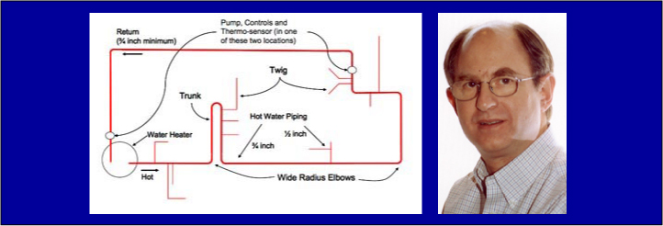

Gary Klein, President of Gary Klein & Associates has been intimately involved in energy efficiency and renewable energy since 1974. He has been involved with national codes and standards and incentive programs including ICC, IAPMO, ASHRAE, EPA Energy Star and WaterSense, LEED and NAHB. One fifth of his career was spent in the Kingdom of Lesotho, the rest in the United States. Mr. Klein has a passion for hot water: getting into it, getting out of it and efficiently delivering it to meet customers' needs.
After serving 19 years with the California Energy Commission, he has provided consulting on sustainability since 2008. Mr. Klein received a BA from Cornell University in 1975 with an Independent Major in Technology and Society with an emphasis on energy conservation and renewable energy.

