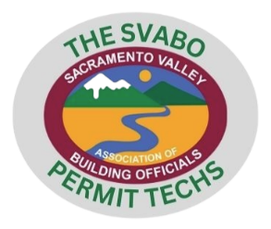
The SVABO Permit Techs Agenda

Date: April 10th, 2024 Time: 4:00pm Location: Microsoft Teams
Attendance: Total meeting minutes:

Brief recap of March meeting
- Building Safey Month – May 2024
- Monthly Newsletter – Check out the newsletter
- ADUs/JADUs
  - Addressing
  - Plans (resources and requirements)
Add in recap from techs
- Results of Software Permitting Survey
- Notice of Violation / Stop Work Order
  - Procedures
  - Flowcharts
  - Handouts/Resources
- REMINDER: Contractor’s State License Board – Survey
Any feedback

