Sacramento Valley Association of Building Officials
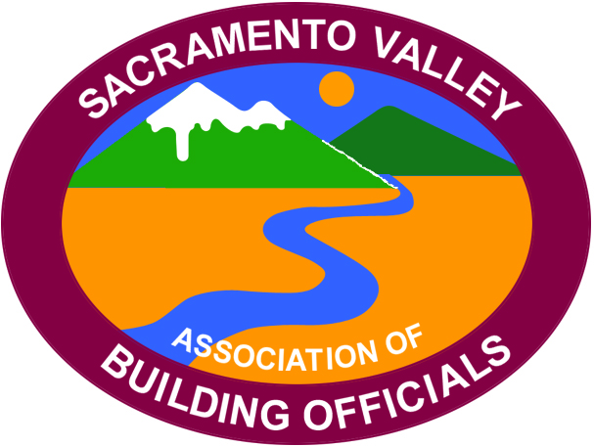

President
Jon May
City of Grass Valley
(530) 274-4717

Vice President
Roxanna Recinos-Serna
City of West Sacramento
(916) 617-4683

Secretary/Treasurer
Will Foote
City of Lincoln
(916) 434-2485

Past President
Nick Henderson
4Leaf, Inc.
(925) 462-5959

Minutes of the May
SVABO General Meeting
Host City: Elk Grove

- Call meeting to order
Meeting called to order by Board President May (BPM) at 10:08 AM

- Thank you to host City Elk Grove
BPM welcomed the host.

- Welcome by host
Brian Frenger

- Flag salute
Led by Eric Simonson

- Self-introductions
Self-introductions of Officers, Board members and all in attendance.

- Review of April Meeting Minutes
Motion to approve meeting minutes by Greg Mahoney. Seconded by Joe Cuffe. Approved by unanimous vote.

- Executive Board Reports:
a. Secretary/Treasurer Report – Will Foote
i. As of June first, our bank balance was 78,950.95

b. Vice-President’s Report – Roxanna Recinos-Serna
i. No June meeting for general members. Next meeting set for July 14th, 2023
ii. Next meetings host- City of Folsom
iii. Today is the last day to sign up for the institute!

c. President’s Report – Jon May
i. The outreach committee has completed the job in Lincoln, huge accomplishment. BP Jon May recognized several of our contributors.
ii. Our website is coming along great. We are continuing to reach out to other chapters and government offices, increasing our collaboration efforts. Check out the website!

d. Past-President’s Report – Nick Henderson- Nothing to report

- Code Quiz – Denise Reese

- Committee Chair Reports
  - Code Review and Development – Bill Rodgers and Jay Hyde
    - Code development is monitoring mid-cycle changes and is scheduled to report on upcoming changes in September.
    - L.A. Basin chapter has been very welcoming and we look forward to attending more of their meetings.

  - Education Committee – Terry Knox and Steve Burger
    - 700+ students have signed up for the institute!
    - Discussion about relocating to a larger venue is underway.

- Outreach Committee – Rick Kelley
- The Lincoln project is complete!
- Citrus Heights project is starting up.
- Discussion about SVABO starting a cashapp/venmo account to get donations via our website.

- Scholarship Committee – Don Wilden-Not present

- Permit Technician Committee – Megan Gideon
- The committee meeting (2nd Wednesday of the month) is moving back to 4PM in June.
- Talks of having on-site committee meetings.

- Event Committee – Andrea Coley
December 2nd is the installation dinner at Lake Natoma Inn, Folsom

- Agency Reports
  - CALBO – Doug Hughes
    - Ed week coming up-changed venue from San Ramone to Burlingame. The southern CA venue TBA.
    - ABM scheduled for April 21st-25th in Indian Wells
    - Legislative update- AB 42, AB 1332, AB 468, SB 423

  - League of Cities- Charles Anderson
    - SB 9. Southern CA lawsuit filed. SB35

  - California Energy Commission – Alan Wong
    - Community shared solar.
    - New website for the inflation reduction act. See CEC website.
    - Presentations available in the online resource center.
    - 2025 energy code pre-rule making has started.

  - ICC – Karyn Beebe
Introduced herself to the membership with a brief bio.
See monthly newsletter here
https://www.iccsafe.org/advocacy/gr-monthly-update

  - HCD – Mitchell Baker No report (presenting)

  - DSA –Eric Driever No report

  - CSLB – Kathrine White No report

  - CCIBC –
i. A bill is currently up to amend the certified designer title act which will clarify language and adding a certified commercial interior designer title.
CBOAC – Andrea Coley
- Annual board meeting is set for June 3rd (online)
- ABM set for October 29th.
Training on tiny homes via webinar May 17th

i. CBSC – Beth Maynard
Currently administering their 45-50-day comment period- See website for more info.
Working in the intervening supplement (the blue pages) for July 2024.
Executive director Mia Marvelli is leaving the building standards commission.

j. CalFire – No report

3. Old Business
Handouts for the institute will be emailed Monday. No handouts will be given in person. Shasta ICC chapter collaboration with our scholarship committee discussed.

4. New Business- None reported

5. Announcements
Announcement for ADA coordinators; The DOJ is checking jurisdictions ADA transition plans.

6. 50/50 Raffle
Won by Craig Sarmento, donated back to SVABO. Thank you, Craig!

7. Today’s Program – by Mitchell Baker (HCD)
Topic: Manufactured Homes

- Lunch

- Adjourn

Meeting adjourned at 12:38 PM

Respectively Submitted,
Will Foote
SVABO Secretary/Treasurer

