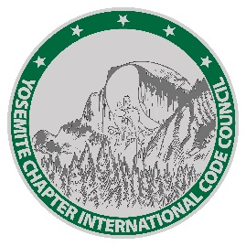

2025
BOARD OF DIRECTORS

PRESIDENT
Will Foote
City of Lincoln

VICE PRESIDENT
Mike Toledo
City of Folsom

SECRETARY
Randall Befort County of Placer

TREASURER
Joel Rushing City of Roseville

PAST PRESIDENT
Roxanna Recinos-Serna
City of W. Sacramento

SERGEANT AT ARMS
Andrea Coley Bureau Veritas

DIRECTORS AT LARGE
Bill Rogers – BPR Joe Cuffe – Citrus Heights
Terry Knox – Shums Coda
Thanks to our sponsors!


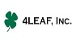



Sacramento Valley Association
of Building Officials, Yosemite Chapter, Napa Solano Chapter
Joint Chapter Meeting Agenda
August 14, 2025, 10:00 AM to 2:00 PM
Simpson Strong-Tie
5151 S. Airport Way, Stockton, CA 95206
2025
YICC Officers:

PRESIDENT
Danis Isho
City of Tracy

VICE PRESIDENT
Ramon Valencia
City of Tracy

SECRETARY
Mohamed Mahmoud
City of Stockton

TREASURER
Denise Frazier
City of Merced

- Welcome and Call Meeting to Order

- Thank you to Host
Simpson Strong-Tie
Don Wilden, Territory Manager

- Flag Salute

- Self-Introductions - Board Members, Attendees

- Review of Meeting Minutes
July Minutes (SVABO)

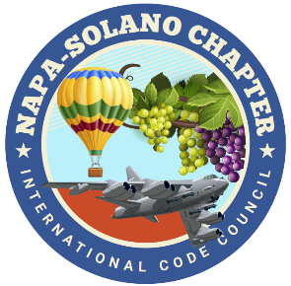

2025
Napa Solano
ICC Officers:

PRESIDENT
Brian Frenger
City of Elk Grove CSG

VICE PRESIDENT
Nandi-Loggins Glover
Solano Economic
Development

SECRETARY
Rachel O’Shea
City of Benicia

TREASURER
Priscilla Ramirez
City of Benicia

July Minutes (YICC)
July Minutes (NSICC)
- Executive Board Reports
6.1 President – Will Foote (SVABO)
- Next Meeting: Elk Grove/ MEP code changes (Hybrid via zoom)

6.2 President – Danis Isho (Yosemite)
- Treasurer’s Report – (Denise Frazier)
- September Meeting – Hybrid Meeting
- Upcoming Class –

  - President – Brian Frenger (Napa Solano)
  - Treasurer’s Report –
  - September Meeting-
  - Upcoming Class –

- Code Quiz- Denise Reese (BPR Consultants)

- Program
11:30 AM – 12:30 PM: Test Lab Tour
12:30 PM – 1:00 PM: Lunch
1:00 PM – 2:00 PM: Test Lab Tour

- Announcements/Adjournment

