Sacramento Valley Association of Building Officials
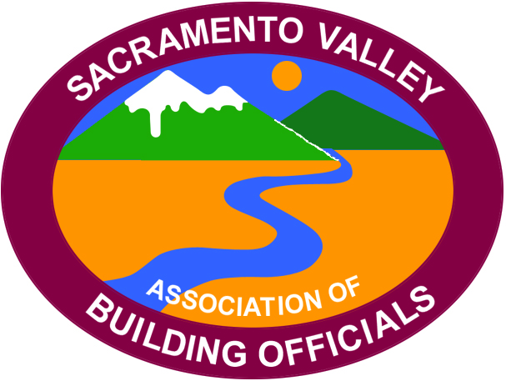

President
Jon May
City of Grass Valley
(530) 274-4717

Vice President
Roxanna Recinos-Serna
City of West Sacramento
(916) 617-4683

Secretary/Treasurer
Will Foote
City of Lincoln
(916) 434-2485

Past President
Nick Henderson
4Leaf, Inc.
(925) 462-5959

Minutes of the August, 11th 2023
SVABO General Meeting

- Call meeting to order
Meeting called to order by Board President May (BPM) at 10:06 AM with 20 people in attendance and 14 people online.

- Thank you to host City (Sacramento)
BPM welcomed the host Bob Latz

- Welcome by host
Thank you, Bob Latz,

- Flag salute
Led by Andrea Coley

- Self-introductions
Self-introductions of Officers, Board members and all in attendance.

- Review of July Meeting Minutes
Motion to approve meeting minutes by Andrea Coley. Seconded by Terry Knox. Approved by unanimous vote.

- Executive Board Reports:
a. Secretary/Treasurer Report – Will Foote
The account as of 8-1-2023 holds 45,338.59

b. Vice-President’s Report – Roxanna Recinos-Serna
Next meeting is set for SEPT 8th to be hosted by the city of Lincoln- the code development committee will be presenting on mid-year changes.

c. President’s Report – Jon May
Presented by-laws changes, separating the secretary/treasurer roles (to be voted on in the October general meeting. Spoke about accounting concerns in not using a professional management company.

d. Past-President’s Report – Nick Henderson
Not present

- Code Quiz – Denise Reese (BPR Consulting)

- Committee Chair Reports
  - Code Review and Development – Bill Rodgers/ Jay Hyde
Next meeting set for August 18th (hybrid) at BPR in Roseville. Mid-year review, handout to come soon. We are continuing participation with the L.A. Basin chapter’s code development committee.

b. Education Committee – Terry Knox/ Steve Burger
Moving forward with two classes in September. We are hard at work for next years institute. If you would like to teach a class please contact the board or education committee members.

- Outreach Committee – Rick Kelley/ Craig Sarmento
Five outreach projects complete this year! Looking into wrapping up previous commitments (TBD). Discussed project sponsorship and Christmas party award attendees.

- Scholarship Committee – Don Wilden
Not Present- BPM addresses the Atkins scholarship applications are complete with announcements to come.

- Permit Technician Committee – Megan Gideon
The August 9th meeting had around 20-30 attendees. Thanks to Elk Grove. Looking for October meeting volunteer to share for how they process permits in their jurisdiction.

- Event Committee – Andrea Coley
December 2nd is the installation dinner at Lake Natoma Inn in Folsom.

- Agency Reports
  - CALBO – Brady Guertin
Calbo ed week coming up. The legislators are currently in recess. Brady has hosted two meetings for legislative updates which can be found on Calbo’s website. Changes to state law will be announced in November. Touched base on three major bills AB 1332, AB42 and AB 468 (good for code enforcement). Please check Calbo’s website for legislative updates.

  - League of Cities- Charles Anderson
Not present

  - California Energy Commission – Allen Wong (Greg Mahoney)
Energy code index is available in electronic format on the CEC’s website. Energy commission is scheduled to reformat the energy code, they are looking for help. If interested please contact Alan Wong of the CEC.

  - HCD- Mitchel Baker
Not present

  - DSA- Eric Driever
Not present

  - ICC – Karyn Beebe
Today’s presenter

  - CSLB –Kathrine White
Not present

  - CBOAC – Andrea Coley (Bob Ivie)
COBAC’s ABM is scheduled for October 29th thru November 1st in Monterey

  - CBSC – Laura Mills (Kevin Day-Acting executive director)
Introduction to the members. June and August commission meetings are complete with info to come on their website. Late September state agencies will be meeting to discuss future model code adoption, more to come. Sign up for CBSC mailing list.

  - CalFire – Tim
CFPI conference is set for March 18th thru 22th 2024 in Santa Barbara. Certification week by the office of the state fire marshal October 2ns thru 8th in Sacramento.

  - ICC Region 1- Tim
All chapter meeting TBA in September.

  - CCIDC- Rose Wiebe
August 16th SB816 will be going into hearing, please support this effort.

- Old Business
None

- New Business
We are posting newsletters, ICC, Calbo etc.… to our website, CHECK IT OUT. The next permit tech meeting will have Citrus Heights presenting.

- Announcements
Code questions on a monthly basis.

- 50/50 Raffle
VP Roxanna won 20$!

- Today’s Program – by Karyn Beebe ICC government relations

Topic: update and changes to the ICC code development process.

- Lunch

16. Adjourn
Meeting adjourned at 12:36 PM

Respectively Submitted,
Will Foote
SVABO Secretary/Treasurer

