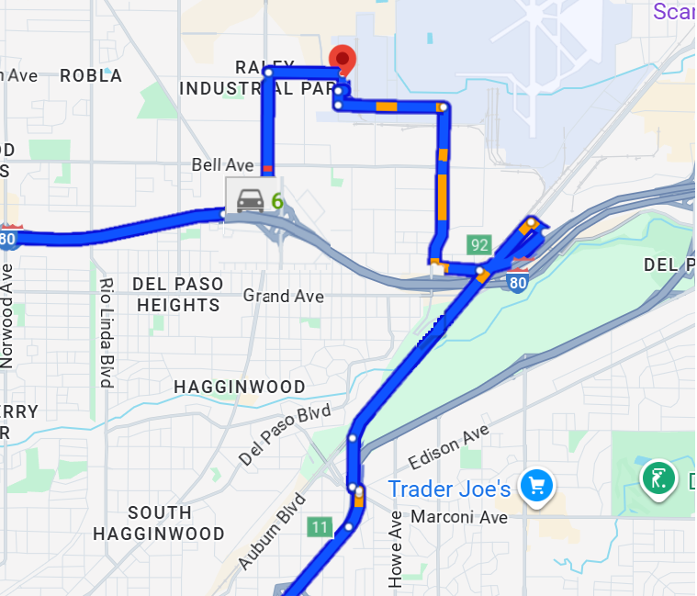
Driving From North Bound Ca-99  - Take Exit 11 for Marconi Ave.  - Use the left 2 lanes to take the ramp to Marconi Ave.  - Turn left onto Marconi Ave.  - Continue onto Arcade Blvd.  - Turn right onto Marysville Blvd.  - Continue onto Raley Blvd.  - Turn right onto Main Ave.  - Turn right onto Lang Ave.  - Turn left onto Villara Ln. | Driving East on I-80  - Take Exit 91 for Raley Blvd / Marysville Blvd.  - Keep left, following signs for Marysville Blvd N  - Turn left onto Raley Blvd.  - Turn right onto Main Ave.  - Turn right onto Marysville Blvd.  - Turn right onto Lang Ave.  - Turn left onto Villara Ln

